* **Name of the Activity**: Title of the Activity: Webinar on “Challenges in Environmental Microbiology”
* **Type of the Activity**: National level Webinar
  + **Organizing Department**: Department of Botany, Chakdaha College
  + **Date and time of the activity**: 31.08.2020
  + **Number of participants**: 787
  + **Speakers:**
    - Prof. (Dr.) Sankar Kumar Ghosh, Hon’ble Ex-Vice-Chancellor, University of Kalyani, W.B. (Chief Guest)
    - Prof. (Dr.) Chandan Sengupta (retired), Department of Botany, University of Kalyani, W.B. (Guest of Honor)
    - Dr. Ranadhir Chakraborty, Senior Professor, Dept. of Biotechnology, University of North Bengal, W.B. (Resource person)
    - Dr. Bernard F. Rodrigues, Senior Professor, Dept. of Botany, Goa University (Resource person)
* **Activity report:**

A number of participants (including faculty members, research scholars, students) attended the webinar from different parts of India. There was a brief discussion on different areas of environmental microbiology and several challenges. Prof. Dr. Sankar Kumar Ghosh, Hon’ble Ex-Vice-Chancellor, University of Kalyani, W.B. was chief guest in this webinar and he enlightened us by his valuable words regarding his long work experience in biotechnology. He gave a detailed view of environmental microbiology and its implications. Next, Prof. (Dr.) Chandan Sengupta (retired), Department of Botany, University of Kalyani, W.B. was there who acted as guest of honor. Dr. Sengupta is an eminent scholar in environmental microbiological work especially in soil microbiology. He briefly described how the environmental pollutants can be degraded with the use of microbes, especially PGPR. Dr. Ranadhir Chakraborty, Senior Professor, Dept. of Biotechnology, University of North Bengal, W.B was one of the resource persons who gave a detailed view on the application of microbial biotechnology and how gene editing can help and improve the quality of specific traits. After that there was Dr. Bernard F. Rodrigues, Senior Professor, Dept. of Botany, Goa University who described the role of AM fungi and reclamation of iron ore mines wastelands. Dr. Swagata Das Mohanta, Principal, Chakdaha College was Patron of this webinar. There was a Question-Answering session at the end of lectures. At last, successful completion of the webinar was done with a vote of thanks.

* **Outcome of the seminar:**
  + 1. 1.It was a brief discussion on microbes-environment interaction especially, how microbes are helping in maintaining environmental balance.
    2. 2.It was a quite knowledge enriching session on the area of bioremediation i.e. how the toxic pollutants can be degraded into less toxic ones by using microbes in a sustainable way.
    3. 3.Different challenges of environmental microbiology were covered in brief here.
* **Photographs of the programme:**

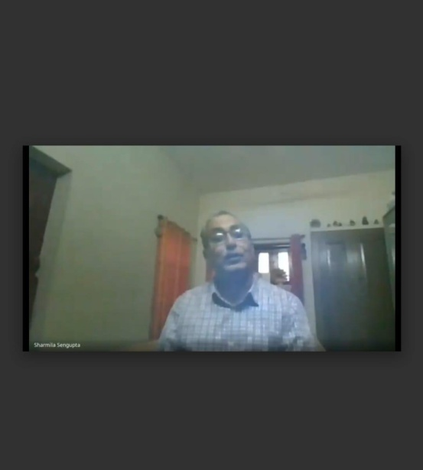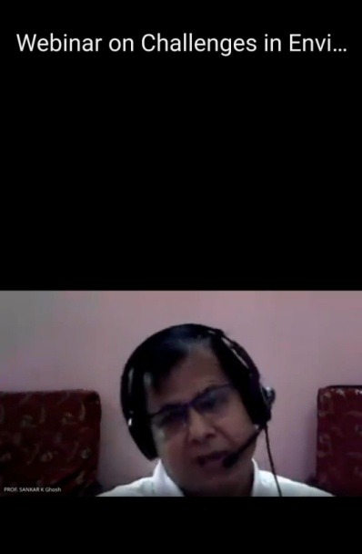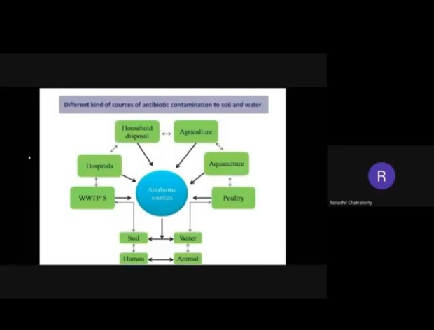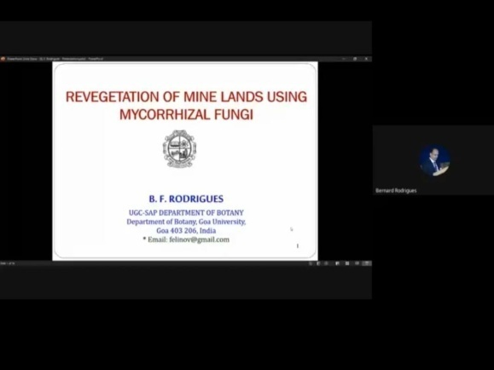

* **Link of the activity**: <https://youtu.be/upQ287FBKeU>

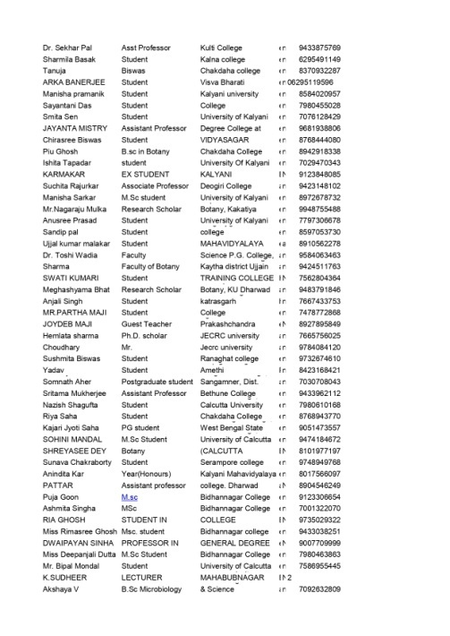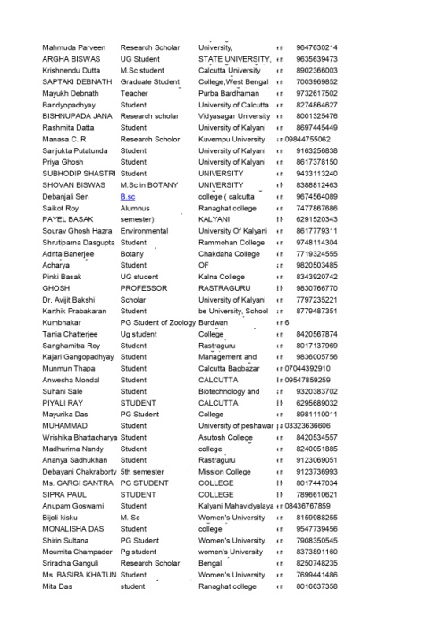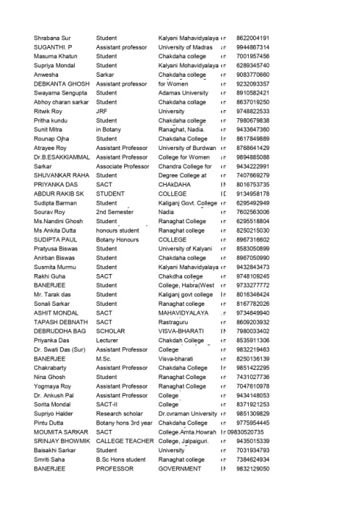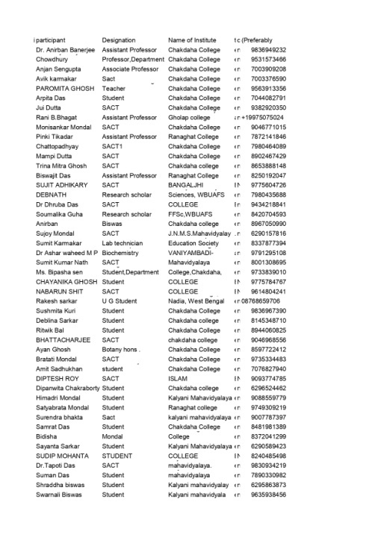Registration List: